REŠITVE PREVERJANJA
- NALOGA
 | mirror
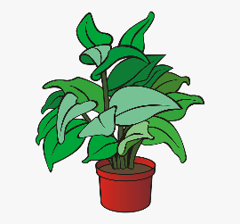 | bookcase
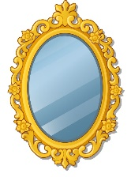 | plant
 | cooker
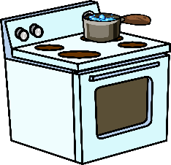 | phone

- NALOGA
The apple is IN FRONT OF the bed.
The cat is UNDER the table.
The lamp is BETWEEN the sofa and the armchair.
The umbrella is ON the floor.

- NALOGA
The plant is behind the sofa.
The mouse is next to the chair/between the chair and the umbrella.
The ball is on an armchair.
The orange flower is in the vase.

- NALOGA
1.kitchen 2.living room 3. Bedroom 4. Bathroom

- NALOGA
A PARROT/A LION

- NALOGA
It is big. It has got scales. It is green. Is has got sharp teeth. It hasn’t got whiskers. It can swim. It can’t jump. (CROCODILE)
It is small. It has got wings. It has got eyes. It hasn’t got hair. It can fly. It can’t run. (BUTTERFLY)

- NALOGA
No, it hasn’t. Yes, it has. / No, it hasn’t. Yes it has. / Yes, it has. Yes it has.

- NALOGA
FLAMINGO, GORILLA, LION

- NALOGA
This is the zebra. It lives in Africa in Savannah. It is medium size. It has got white and black stripes. It has got a big head, a big nose and a big mouth. But it has got a small eyes. It has got short body, but long legs and a long tail. It can run and jump. But it can’t climb or fly. Zebras are not dangerous. They are beautiful animals.

