Dragi učenec, učenka.
Pred tabo je preverjanje znanja. Pred reševanjem nalog ponovi učne vsebine v učbeniku od str. 58. dalje. Dodatne razlage in vaje so v zvezku, DZ in na učnih listih. Preverjanju nameni vsaj 2 šolski uri!
Z (M) so označeni minimalni standardi znanja, z * pa zahtevnejši standardi znanja!

PRESENT SIMPLE TENSE
1. Ask and answer. Dopolni z DO, DON’T, DOES ali DOESN'T. (M)

1. _______________ Bill do his homework on time? Yes, he _________________.
2. _________________ Ted and Susan dance? No, they _________________.
3. _______________ you live in Barcelona? Yes, I _________________.

2. Complete the sentences with the right form of the verb. Dopolni povedi z ustrezno glagolsko obliko.
1. My aunt ________________________________ (drink) tea after lunch.
2. Barbara __________________________________ (not send) many emails.
3. Many students ___________________________ (eat) a lot of crisps.
3. Complete the sentence. Dopolni povedi, obkroži pravilen odgovor v času Present Simple. (M)

1. Sadie _____________________ meat.
a) never eat b) never eats c) eats never

2. Jim______________________ his car.
a) doesn’t often wash b) don’t often wash c) often doesn’t wash

3. __________Mary ________________________ her homework on time?
a) Do … always do b) Does … do always c) Does … always do

4. Megan ______________________ milk and fruit for breakfast.
a) has usually got b) has usually c) usually has

5. Anna and Jim ______________________ school meals.
a) doesn’t sometimes like b) don’t sometimes like c) doesn’t like sometimes

*4. Make Wh-questions (where, who….) for the given (underlined) answers. Tvori vprašanja z Wh-vprašalnicami (npr. where, who, …) za podčrtan del odgovorov.
1. ________________________________________? He goes to school at 8 o’clock.
2. _________________________________________? I often have pasta for lunch.
5. Write complete sentences. Napiši povedi, prislove pogostosti vstavi na pravo mesto.
- Sadie and Joe have breakfast. (usually, at 7.30)
Sadie and Joe usually have breakfast at 7.30.

a) Jay and Fiona don’t visit their parents. (always, at weekend)
___________________________________________________________________

b) Ben and Tom are late for school. (often, in the morning)
___________________________________________________________________

THERE IS, THERE ARE + A/AN/SOME/ANY; COUNTABLE AND UNCOUNTABLE NOUNS; FOOD

6. Circle the correct answer A, B or C. Obkroži pravilen odgovor A, B ali C. (M)
a) _________________ water in the fridge?
A) Is there any B) Is there a C) Are there any

b) ______________ pasta in the cupboard.
A) There are some B) There is a C) There is some

c) _________________ bananas on the table?
A) Is there any B) Is there a C) Are there any

d) There is __________________ tomato in the basket and _______________ potatoes.
A) an, some B) some, some C) a, some

7. Are the following nouns countable or uncountable? List them in the chart under a suitable heading. Ali so spodnji samostalniki števni ali neštevni? Uvrsti jih na pravilni seznam v tabeli.
Nouns: toast, egg, vegetables, bread, sandwich, cherries, omelette, strawberries, coffee, steak, butter, burgers

SINGULAR (EDNINA) | PLURAL (MNOŽINA) | UNCOUNTABLE NOUNS (NEŠTEVNI)

8. Complete the sentences with THERE IS or THERE ARE in positive, negative or question form. Dopolni povedi z THERE IS ali THERE ARE v trdilni, nikalni ali vprašalni obliki. (M)
a) _____________________ any plants in the classroom? No, ________________
b) ______________________ a clock in the classroom? Yes, _________________
c) ______________________________ any carrots in the fridge.
d) ____________________________________ a computer in our classroom.

9. Complete the sentences with THERE IS or THERE ARE in positive, negative or question form and a, an, some or any. Dopolni povedi z THERE IS ali THERE ARE v trdilni, nikalni ali vprašalni obliki in a, an, some ali any.
- Is there any bread? Yes, there is.
There is some bread.
a) Look! _______________________________________________ big spider.
b) __________________________________________ bottles of apple juice.
c) I’m hungry. _________________________________________________ pasta?
d) I can’t make vegetable lasagne. ________________________________cheese.
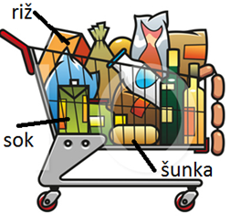
*10. Look at the picture of a shopping trolley and make 5 sentences with there is/isn't, there are/aren't + SOME/ANY or A/AN + a noun. Look at an example.
Oglej si sliko nakupovalnega vozička in tvori (dopolni) 5 povedi z “there is/isn’t”, “there are/aren’t” ter “some/any” ali “a/an” + samostalnik. Glej primer!
NOT in the shopping trolley (NI v nakupovalnem vozičku):
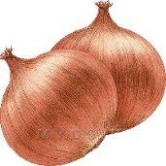

Example: There is some fish (in the trolley).

There is ____________________________________________________________.

There are ___________________________________________________________.

There ______________________________________________________________.

There isn’t __________________________________________________________.

There aren’t _________________________________________________________.

PREPOSITIONS OF PLACE
11. Look at the picture and fill in the blanks with the missing preposition. (M) Choose among: in, on, above, under, in front of, between, next to, in the middle. Oglej si sliko in dopolni vrzeli z ustreznim predlogom. Izbiraj med: in, on, above, under, in front of, between, next to, in the middle.
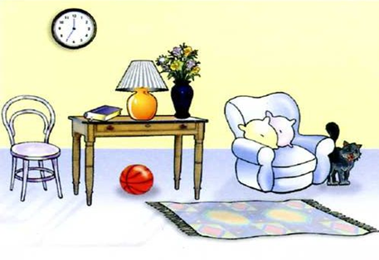
1. The clock is ____________ the wall.

2. The table is ___________________
the chair and armchair.

3. The ball is _____________the table.

4. The cat is ____________________
the armchair.
5. The rug is _____________ the floor.

6. The table is ___________________
the clock. (pred)

7. The table is ____________________________________________of the room.

VOCABULARY: HOMES, ROOMS AND FURNITURE; TIME, DAILY ROUTINES
12. A) Name different rooms (in the boxes), pieces of furniture and other parts of the house in the picture. Poimenuj sobe v hiši (piši v pravokotnike na sliki) in kose pohištva ter druge označene dele hiše označene s številkami (v tabelo). (M)
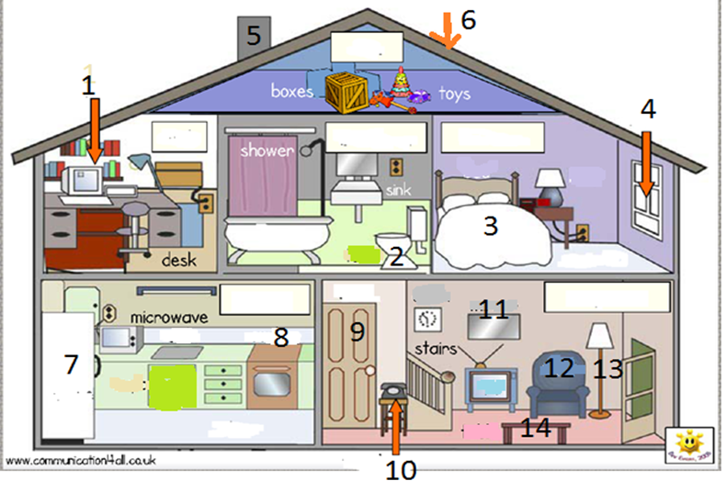

1 | 8
2 | 9
3 | 10
4 | 11
5 | 12
6 | 13
7 | 14

12 B) GOVORNO SPOROČANJE
Ponovno si oglej sliko hiše. Tvori povedi in jo opiši. V pomoč so ti spodnja vprašanja.

Kateri prostori so spodaj/v pritličju. Kateri zgoraj?
Poimenuj kose pohištva in opreme ter povej, v katerem prostoru so.
Kje se nahajajo posamezni predmeti (na, v pod, med, …)?

Primeri:
There is a kitchen and a living room downstairs.
There is an armchair in the living room.

13. GOVORNO SPOROČANJE

A) Look at Mia’s bedroom and describe it. Opiši sobo. Tvori čimveč povedi.

Uporabi:
- There is …, There are…
- Mia has got…
- predloge kraja
- poimenuj kose pohištva, opreme

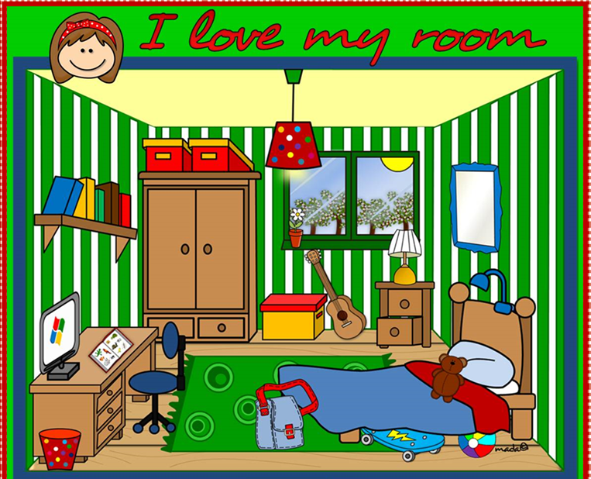
Vir: https://www.liveworksheets.com/worksheets/en/English_as_a_Second_Language_(ESL)/There_is_-_there_are/I_love_my_room_-_there_is_-_there_are_pg5502do

B) DAILY ROUTINES (DNEVNE RUTINE)

Talk about things you do at home. Talk about your good and bad habits. Opiši stvari, ki jih počneš doma. Govori o svojih dobrih in slabih navadah. (M)

Npr.
I use a computer, watch TV, read books and magazines. I do judo. I always tidy my room on Saturdays. I usually do my homework on time. I often help my dad in the garage. I’m usually very energetic. My bad habit is that I don’t always listen to my parents and eat a lot of chips.

OPOMBA: Če želiš, se lahko pri zadnjih nalogah govornega sporočanja (12 B, 13 A in B) tudi posnameš in mi posnetek oddaš v spletni učilnici ali pa zapišeš odgovore in jih pošlješ po mejlu.

REŠITVE
1..

1. DOES Bill do his homework on time? Yes, he DOESN’T.
2. DO Ted and Susan dance? No, they DON’T.
3. DO you live in Barcelona? Yes, I DO.

2.
1. My aunt __________DRINKS____________ (drink) tea after lunch.
2. Barbara _________DOESN’T SEND______________ (not send) many emails.
3. Many students __________EAT_________ (eat) a lot of crisps.

3.

1. Sadie _____________________ meat.
a) never eat b) never eats c) eats never

2. Jim______________________ his car.
a) doesn’t often wash b) don’t often wash c) often doesn’t wash

3. __________Mary ________________________ her homework on time?
a) Do … always do b) Does … do always c) Does … always do

4. Megan ______________________ milk and fruit for breakfast.
a) has usually got b) has usually c) usually has

5. Anna and Jim ______________________ school meals.
a) doesn’t sometimes like b) don’t sometimes like c) doesn’t like sometimes

4.
1. When does he go to school? He goes to school at 8 o’clock.
2. What do you (often) have/eat for lunch? I often have pasta for lunch.

5.
a) Jay and Fiona don’t always visit their parents at weekend.

b) Ben and Tom are often late for school in the morning.

6.
a) _________________ water in the fridge?
A) Is there any B) Is there a C) Are there any

b) ______________ pasta in the cupboard.
A) There are some B) There is a C) There is some

c) _________________ bananas on the table?
A) Is there any B) Is there a C) Are there any

d) There is __________________ tomato in the basket and _______________ potatoes.
A) an, some B) some, some C) a, some

7.
SINGULAR (EDNINA) | PLURAL (MNOŽINA) | UNCOUNTABLE NOUNS (NEŠTEVNI)
egg | vegetables | bread
sandwich | cherries | coffee
omelette | strawberries | butter
steak | burgers | toast

8.
a) _ARE THERE______ any plants in the classroom? No, THERE AREN'T.
b) ____IS THERE_____ a clock in the classroom? Yes, THERE IS.
c) _____THERE AREN'T_________ any carrots in the fridge.
d) ___THERE IS_________ a computer in our classroom.
9.
a) Look! There is a big spider.
b) There are some bottles of apple juice.
c) I’m hungry. Is there any pasta?
d) I can’t make vegetable lasagne. There isn’t any cheese.
10.
There is some rice/juice/milk/wine in the trolley. ALI There is a packet of juice/rice…

There are some sausages….

There is some ham. + ostale možnosti, ki jih nisi omenil v drugih povedih.

There isn’t any cheese...

There aren’t any onions/apples….

11.
1. The clock is ___ON_____ the wall.
2. The table is ___BETWEEN_____ the chair and armchair.
3. The ball is UNDER the table.
4. The cat is NEXT TO the armchair.
5. The rug is ON the floor.
6. The table is IN FRONT OF the clock. (pred)
7. The table is IN THE MIDDLE of the room.

12. A)

1 computer | 8 cooker
2 toilet | 9 door
3 bed | 10 telephone/phone
4 window | 11 painting/mirror
5 chimney | 12 armchair
6 roof | 13 lamp
7 fridge | 14 table/coffee table

Prostori:
downstairs: KITCHEN, LIVING ROOM
upstairs: STUDY, BATHROOM, BEDROOM, LOFT/ATTIC

12 B) Primeri:
There is a kitchen and a living room downstairs.
There is an armchair in the living room.
There is a bathroom, a bedroom and a study upstairs.
There is a lamp next to the armchair.
There is a painting above the television. ipd.

13. GOVORNO SPORAZUMEVANJE IN SPOROČANJE

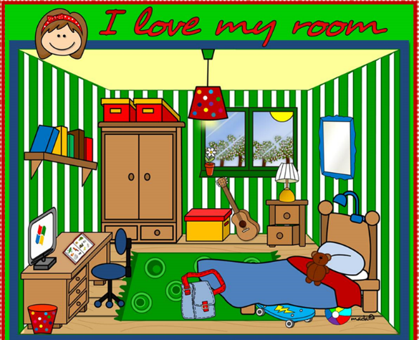
There is a wardrobe next to the window.
There are some books on the bookshelf.
Mia has got a guitar.
The guitar is in front of the window.
There is a lamp above the bed.
The green rug is under the bed./The rug is in the middle of the room.
The rubbish/dustbin/litter bin/bin is next to the desk.
There is a skateboard under the bed.
There is a bag on the floor.
There is a brown teddy bear on the bed.
There is a red/colourful lamp on the ceiling. ipd.

