NARIŠIMO SKUPAJ
MINION:
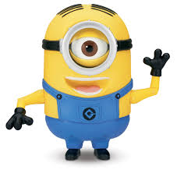
https://www.youtube.com/watch?v=Q_N3k8efsNA

SLADOLED:
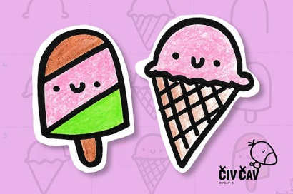
https://www.youtube.com/watch?v=7mbfZSUQ2wY

PIKAPOLONICA:
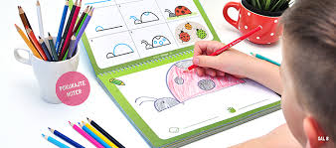
https://www.youtube.com/watch?v=trkEjZDGroc

POŠASTI:
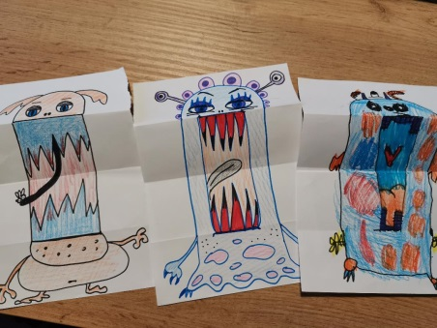
https://www.youtube.com/watch?v=meN-eWeM3Mc

NARIŠI SVOJE POBARVANKE:
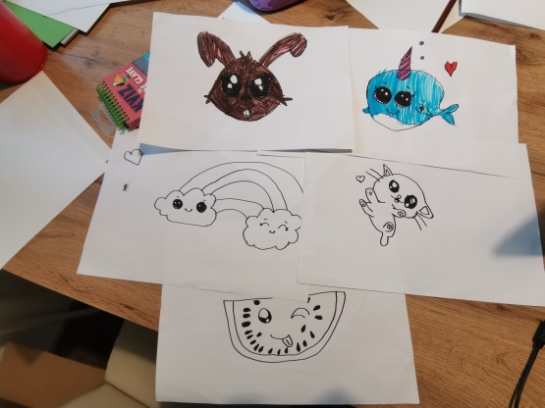
https://www.youtube.com/watch?v=NK9wJYGHo_g
https://www.youtube.com/watch?v=AoMHHfquzz0
https://www.youtube.com/watch?v=GmUegIR7APY
https://www.youtube.com/watch?v=y4WGOeda60w
https://www.youtube.com/watch?v=jE7rLvgim0s
https://www.youtube.com/watch?v=PEx1Ugsqjso

POVEZAVA DO BREZPLAČNIH POBARVANK:
https://www.janafak.net/freecoloringbook

